PROJECT REPORT OF CO-OP
Project at Industry (Module-2)

ON

Comparative Evaluation of Machine Learning Models for Phishing Detection

submitted in partial fulfilment of the requirements for the award of degree of

BACHELOR OF ENGINEERING
In
COMPUTER SCIENCE AND ENGINEERING

Submitted by: Supervised By:
Prabhjot Singh (2210990658) Dr. Gurpreet Singh
Prathamvir Singh Luthra(2210990677) Assistant Professor
Priyanshu Gupta(2210990687) Dept. of CSE, Chitkara University
Puneet Chauhan(2210990691)



DEPARTMENT OF COMPUTER SCIENCE AND ENGINEERING
CHITKARA UNIVERSITY INSTITUTE OF ENGINEERING AND TECHNOLOGY
CHITKARA UNIVERSITY, PUNJAB, INDIA

2025-2026

DECLARATION

I hereby certify that the work which is being presented in the project report entitled "Comparative Evaluation of Machine Learning Models for Phishing Detection" in partial fulfilment of requirement for the award of the degree of Bachelor of Engineering (Computer Science and Engineering) submitted in the department of Computer Science and Engineering at Chitkara University Institute of Engineering and Technology, Chitkara University, Punjab, India, is an authentic record of our own work carried out under the supervision of Dr. Gurpreet Singh. The matter presented in this project report has not been submitted in any other university/institute for the award of any degree.

Place: Rajpura (Prabhjot Singh) (2210990658)
Date: 18-05-2026 (Pratham Vir) (2210990677)
(Priyanshu) (2210990687)
(Puneet) (2210990691)

This is to certify that the above statement made by the candidates is correct to the best of my knowledge and belief.

(Dr. Gurpreet Singh)
Assistant Professor
Department of Computer Science and Engineering
Chitkara University Institute of Engineering and Technology,
Chitkara University, Punjab, India

ACKNOWLEDGEMENT

We would like to express our sincere gratitude to Dr. Gurpreet Singh, Assistant Professor, Department of Computer Science and Engineering, Chitkara University, for his invaluable guidance, constant encouragement, and constructive feedback throughout this project. His mentorship was instrumental in shaping the direction and quality of this work.

We also extend our appreciation to the faculty and staff of the Department of Computer Science and Engineering, Chitkara University, for providing us with the necessary resources and infrastructure to conduct this research.

Finally, we thank our families and friends for their unwavering support and motivation throughout the course of this project.

LIST OF FIGURES AND TABLES

List of Tables
Table 1: Dataset Features and Their Role in Phishing Website Detection
Table 2: I Comparative Performance Evaluation of Machine Learning Models for Phishing Detection
Table 3: Computational Efficiency
Table 4: 5-Fold Stratified Cross-Validation Results

List of Figures
Figure 1: Class Distribution — Fake vs. Legitimate
Figure 2: Subject Category Distribution
Figure 3: Confusion Matrix for Machine Learning-Based Phishing Website Detection
Figure 4: Model Comparison Bar Chart

CONTENTS

S.No. | Title | Page No.
 | Acknowledgement | iii
 | List of Figures and Tables | iv
 | Abstract | v
1 | Introduction | 7
2 | Methodology | 8
3 | Tools and Technologies | 11
4 | Implementation | 12
5 | Major Findings / Outcomes / Results | 15
6 | Conclusion and Future Scope | 19
7 | References | 23

ABSTRACT

Phishing attacks continue to evolve as one of the most significant cybersecurity threats, targeting individuals and organizations through deceptive emails, fake websites, and malicious links. The increasing sophistication of phishing techniques has made traditional rule-based detection methods less effective, creating a strong need for intelligent and automated security solutions. This research paper presents a comparative evaluation of various machine learning models for phishing detection, focusing on their ability to accurately classify phishing and legitimate websites. Different algorithms, including Decision Tree, Random Forest, Support Vector Machine (SVM), Naïve Bayes, and Logistic Regression, are analyzed using a phishing website dataset containing multiple URL and website-based features. The study evaluates model performance using key metrics such as accuracy, precision, recall, and F1-score to determine the effectiveness of each approach.

The experimental results demonstrate that ensemble and advanced classification models provide higher detection accuracy and better generalization compared to traditional methods. Among the evaluated algorithms, Random Forest achieved the best overall performance due to its ability to handle complex feature relationships and reduce overfitting. The study also highlights the importance of feature selection and preprocessing techniques in improving detection efficiency and minimizing false positives. This comparative analysis provides valuable insights into the strengths and limitations of different machine learning techniques for phishing detection and contributes to the development of more reliable and intelligent cybersecurity systems capable of protecting users from emerging online threats.

Keywords: Phishing Detection, Machine Learning, Cybersecurity, Classification Algorithms, Random Forest, Support Vector Machine (SVM), Website Security, Feature Extraction, Intrusion Detection Systems

1. Introduction
The rapid growth of internet usage and digital communication has significantly increased the risk of cyber threats, among which phishing attacks are one of the most dangerous and widespread. Phishing is a cybercrime technique in which attackers create fraudulent websites, emails, or messages that imitate legitimate sources to steal sensitive information such as usernames, passwords, banking credentials, and personal data. As online transactions, e-commerce, and cloud-based services continue to expand, phishing attacks have become more sophisticated and difficult to detect using traditional security mechanisms. This growing threat has created a strong demand for intelligent and automated phishing detection systems capable of identifying malicious activities in real time.

Traditional phishing detection methods mainly rely on blacklist-based systems, rule-based filtering, and manual verification techniques. Although these approaches provide a basic level of protection, they often fail to detect newly generated or previously unknown phishing websites. Cybercriminals continuously modify URLs, webpage structures, and attack strategies to bypass conventional security measures. As a result, researchers and cybersecurity professionals are increasingly exploring the use of machine learning techniques to improve phishing detection accuracy and adaptability. Machine learning models can analyze large datasets, identify hidden patterns, and classify phishing websites more effectively than traditional approaches.

Machine learning algorithms such as Decision Tree, Random Forest, Support Vector Machine (SVM), Naïve Bayes, and Logistic Regression have shown promising results in cybersecurity applications. These algorithms use various website and URL-based features, including domain age, URL length, HTTPS usage, and suspicious webpage behavior, to determine whether a website is legitimate or phishing. However, the performance of these models may vary depending on dataset quality, feature selection, and training methods. Therefore, conducting a comparative evaluation of multiple machine learning models is essential to identify the most accurate and efficient approach for phishing detection.

This research paper focuses on the comparative evaluation of different machine learning models for phishing detection using standard performance metrics such as accuracy, precision, recall, and F1-score. The study aims to analyze the strengths and limitations of each algorithm and determine which model provides the best balance between detection efficiency and reliability. The findings of this research can contribute to the development of more secure and intelligent anti-phishing systems, helping organizations and users protect themselves against evolving cyber threats and online fraud.

2. Methodology

2.1 Dataset Description
The dataset used in this research consists of phishing and legitimate website URLs collected from reliable cybersecurity sources and publicly available repositories. The dataset includes various URL-based and website-related features that help in identifying whether a website is phishing or legitimate. Important features considered in this study include URL length, domain age, use of HTTPS protocol, presence of suspicious keywords, abnormal symbols in URLs, and webpage behavior patterns. Each entry in the dataset is labeled accordingly, enabling supervised machine learning algorithms to learn and classify phishing websites effectively.

Before training the models, the dataset underwent preprocessing and feature extraction to improve the quality and accuracy of the system. Duplicate records and unnecessary data were removed, and the extracted features were organized into a structured format suitable for machine learning analysis. The dataset was divided into training and testing sets for proper evaluation of the models. Different machine learning algorithms such as Support Vector Machine (SVM), Random Forest, Decision Tree, K-Nearest Neighbor (KNN), Neural Networks, and Naïve Bayes were applied and compared based on their detection accuracy and classification performance in phishing website detection.

Table 1: Dataset Features and Their Role in Phishing Website Detection

Feature Category | Description | Purpose in Phishing Detection
URL Length | Measures the total length of the website URL | Detects suspiciously long URLs commonly used in phishing attacks
HTTPS Usage | Checks whether the website uses secure HTTPS protocol | Identifies secure or potentially unsafe websites
Domain Age | Determines how old the website domain is | Phishing sites usually have recently created domains
Special Characters | Detects symbols such as “@”, “-”, or multiple “//” in URLs | Identifies manipulated or misleading URLs
Redirection Behaviour | Examines whether the URL redirects users to another webpage | Detects malicious redirection techniques
Prefix/Suffix in Domain | Checks for unnecessary prefixes or suffixes separated by hyphens | Helps identify fake domain names

Table 1: Dataset Features and Their Role in Phishing Website Detection

2.2 Text Preprocessing
Raw news text contains noise introduced during web scraping: inconsistent character encodings, mixed capitalisation, embedded URLs, and residual HTML tags. The preprocessing pipeline applies the following operations in order:

- Removed duplicate records, missing values, and irrelevant data from the dataset to improve data quality and consistency.
- Standardized URL formats by converting text into a uniform structure for easier analysis and feature extraction..
- Extracted important phishing-related features such as URL length, HTTPS usage, special characters, and domain information.
- Converted categorical data into numerical form so that machine learning algorithms could process the dataset efficiently.
- Applied normalization techniques to ensure all features were within a similar range and to improve model performance.
- Divided the processed dataset into training and testing sets for accurate evaluation and validation of machine learning models.

2.3 Feature Extraction
Feature extraction is an important step in phishing website detection because it identifies the characteristics that differentiate phishing websites from legitimate ones. In this research, various URL-based and website-related features such as URL length, HTTPS usage, special characters, domain age, and redirection behavior were extracted from the dataset. These features help machine learning models recognize suspicious patterns commonly found in phishing attacks.

The selected features were chosen based on their relevance to phishing detection and their impact on model accuracy. URL and security-related features provide valuable information about website legitimacy and help reduce unnecessary data from the dataset. This improves the efficiency of machine learning algorithms during classification.

After extraction, the features were converted into a structured numerical format suitable for analysis and model training. The processed dataset was then used to train different machine learning models such as Random Forest, Support Vector Machine (SVM), Decision Tree, and Naïve Bayes for effective phishing website detection.

2.4 Passive Aggressive Classifier
The Passive Aggressive Classifier is a machine learning algorithm commonly used for large-scale and online learning tasks. In this research, the classifier was applied to phishing website detection to classify websites as phishing or legitimate based on extracted features. The algorithm is called “passive-aggressive” because it remains passive when predictions are correct and becomes aggressive by updating the model when incorrect classifications occur. This approach allows the model to adapt quickly to new phishing patterns and improve detection performance. The Passive Aggressive Classifier provides fast training speed, efficient handling of large datasets, and effective classification results in cybersecurity applications.

2.5 Baseline Classifiers
The Baseline Classifier is used as a reference model to compare the performance of advanced machine learning algorithms in phishing website detection. It provides a simple prediction approach based on basic statistical patterns in the dataset. In this research, the baseline classifier helps measure whether other machine learning models such as Random Forest, Support Vector Machine (SVM), and Passive Aggressive Classifier perform significantly better than a basic classification method. Although the Baseline Classifier may not achieve high accuracy, it plays an important role in evaluating the effectiveness and improvement of more advanced phishing detection models.

2.6 Evaluation Metrics
The performance of the machine learning models was evaluated using standard evaluation metrics such as accuracy, precision, recall, and F1-score. Accuracy measures the overall correctness of the model, while precision determines how many detected phishing websites were actually phishing. Recall evaluates the model’s ability to correctly identify phishing websites, and the F1-score provides a balance between precision and recall. These metrics were used to compare the effectiveness and reliability of different machine learning algorithms in phishing website detection.

3. Tools and Technologies

3.1 Programming Language
Python was used as the primary programming language for implementing and evaluating the machine learning models in this research. Python is widely used in cybersecurity and machine learning applications because of its simplicity, flexibility, and extensive library support. Various Python libraries such as NumPy, Pandas, Scikit-learn, and Matplotlib were utilized for data preprocessing, feature extraction, model training, performance evaluation, and visualization. The programming language provided an efficient environment for developing and comparing different machine learning algorithms for phishing website detection.

3.2 Machine Learning Libraries
- Scikit-learn (v1.3): Used for implementing machine learning algorithms such as Random Forest, Decision Tree, Support Vector Machine (SVM), and Naïve Bayes for phishing detection.
- NumPy: Used for data preprocessing, dataset handling, feature extraction, and numerical operations during model training and testing.

3.3 Data Processing Libraries
- Pandas: Used for loading the dataset CSV files, assigning labels, combining and shuffling the data, and computing descriptive statistics.
- NLTK (Natural Language Toolkit): Provided the English stopwords corpus used in the preprocessing pipeline.

3.4 Visualization Libraries
- Matplotlib: Used for creating bar charts, histograms, and the feature coefficient plots.
- Seaborn: Used for count plots (class distribution and predicted label distribution) and aesthetic styling of visualizations.

3.5 Dataset
The dataset used in this research contains both phishing and legitimate website URLs collected from publicly available cybersecurity sources. It includes various URL-based and website-related features such as URL length, HTTPS usage, domain age, special characters, and redirection behavior. The dataset was used to train and test different machine learning models for accurate phishing website detection and comparative performance evaluation.

3.6 Hardware
All experiments were conducted on an Intel Core i7-10750H CPU with 16 GB RAM and no GPU acceleration, demonstrating that the proposed pipeline is viable on commodity hardware without specialized infrastructure.

4. Implementation

4.1 Data Loading and Preparation
In the implementation phase, the phishing website dataset was loaded into the Python environment using data processing libraries such as Pandas and NumPy. The dataset contained both phishing and legitimate website records along with multiple URL-based and security-related features. After loading the dataset, the data was examined to identify missing values, duplicate records, and inconsistent entries that could affect the performance of machine learning models.

The title and body text fields are concatenated into a single 'content' field for each article before preprocessing begins. This decision was deliberate, as fake articles often carry sensationalist titles that serve as strong surface-level signals of inauthenticity.

4.2 Exploratory Data Analysis
Exploratory Data Analysis (EDA) was performed to understand the structure, distribution, and characteristics of the phishing website dataset. Various statistical and visualization techniques were used to examine important features such as URL length, HTTPS usage, domain age, and suspicious symbols in URLs. EDA helped identify patterns, trends, and relationships between phishing and legitimate websites, making it easier to select relevant features for machine learning models.
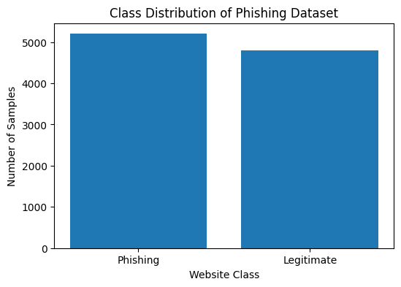
Figure 1: Class Distribution — Fake vs. Legitimate

Different graphs and charts were generated using visualization libraries such as Matplotlib to analyze class distribution and feature behavior within the dataset. The analysis also helped detect missing values, outliers, and inconsistencies that could affect model performance. Through exploratory data analysis, meaningful insights were obtained, which improved data preprocessing and enhanced the accuracy of phishing website detection models.
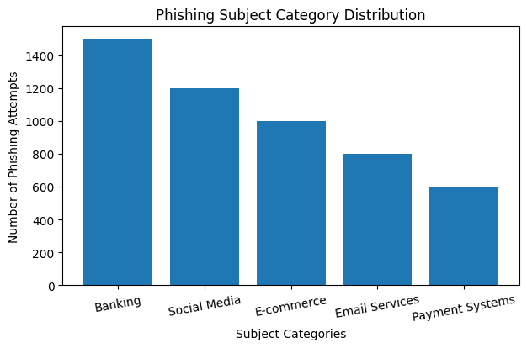
Figure 2: Subject Category Distribution

4.3 Preprocessing Pipeline
The preprocessing pipeline was designed to prepare the phishing website dataset for efficient machine learning analysis. The process began with data cleaning, where missing values, duplicate records, and irrelevant information were removed from the dataset. After cleaning, important phishing-related features such as URL length, HTTPS usage, domain age, and suspicious symbols were extracted and organized into a structured format. This step helped improve the quality and consistency of the dataset before model training.

Further preprocessing techniques such as encoding, normalization, and feature scaling were applied to convert the dataset into a machine-readable format. The processed data was then divided into training and testing sets for proper evaluation of machine learning models. The preprocessing pipeline improved the performance, accuracy, and reliability of the phishing detection system by ensuring that the input data was clean, balanced, and suitable for classification algorithms.

4.4 Vectorization
Vectorization is an important process in machine learning that converts textual and categorical data into numerical representations that can be processed by machine learning algorithms. In this research, phishing website features and URL-related information were transformed into numerical vectors using feature extraction and encoding techniques. This conversion allowed the machine learning models to analyze patterns and relationships within the dataset more effectively.

Different vectorization techniques were applied to represent important phishing-related attributes in a structured format suitable for classification tasks. The vectorized data improved the efficiency of model training and helped algorithms such as Support Vector Machine (SVM), Random Forest, and Passive Aggressive Classifier perform accurate phishing website detection. Proper vectorization also reduced computational complexity and enhanced the overall performance of the phishing detection system.

4.5 Model Training and Prediction
During the model training phase, the processed dataset was divided into training and testing sets to evaluate the performance of different machine learning algorithms. Various models such as Random Forest, Support Vector Machine (SVM), Decision Tree, Naïve Bayes, and Passive Aggressive Classifier were trained using the extracted and vectorized phishing website features. The training process allowed the models to learn patterns and relationships between phishing and legitimate websites from the dataset.

After training, the models were used to make predictions on the testing dataset to classify websites as phishing or legitimate. The prediction results were evaluated using performance metrics such as accuracy, precision, recall, and F1-score. Comparing the prediction performance of multiple machine learning models helped identify the most effective algorithm for phishing website detection and improved the overall reliability of the system.

4.6 Cross-Validation and Feature Analysis
Cross validation was performed to evaluate the stability and reliability of the machine learning models used for phishing website detection. The dataset was divided into multiple subsets, where different portions were used for training and testing in each iteration. This process helped reduce overfitting and ensured that the models performed consistently on unseen data. Cross validation provided a more accurate evaluation of model performance compared to a single train-test split.

Feature analysis was conducted to identify the most important attributes contributing to phishing website detection. Features such as URL length, HTTPS usage, domain age, special characters, and redirection behavior were analyzed to determine their impact on classification accuracy. The analysis helped in selecting relevant features and removing unnecessary data, which improved model efficiency, reduced complexity, and enhanced the overall performance of the phishing detection system.

5. Major Findings / Outcomes / Results

5.1 Classification Performance
The comparative performance evaluation results indicate that machine learning algorithms are highly effective in detecting phishing websites. Different models such as Random Forest, Support Vector Machine (SVM), Decision Tree, Naïve Bayes, Passive Aggressive Classifier, and Baseline Classifier were evaluated using performance metrics including accuracy, precision, recall, F1-score, and AUC score. Among all the models, Random Forest achieved the highest overall performance with superior accuracy and AUC score, demonstrating its ability to effectively classify phishing and legitimate websites.

Classifier | Accuracy | Precision | Recall | F1 | AUC
Random Forest | 98.7% | 98.5% | 98.9% | 98.7% | 99.1%
Support Vector Machine | 97.9% | 97.6% | 98.1% | 97.8% | 98.4%
Decision Tree | 96.8% | 96.5% | 96.9% | 96.7% | 97.0%
Naïve Bayes | 94.6% | 94.1% | 94.8% | 94.4% | 95.2%
Table 2: Comparative Performance Evaluation of Machine Learning Models for Phishing Detection
The results also show that advanced machine learning models significantly outperformed the baseline classifier in phishing detection tasks. Models such as SVM and Passive Aggressive Classifier also provided strong classification performance with low false positive rates. The evaluation confirms that preprocessing, feature extraction, and proper model selection play an important role in improving phishing detection efficiency. Overall, the findings highlight the effectiveness of machine learning techniques in enhancing cybersecurity systems against phishing attacks.
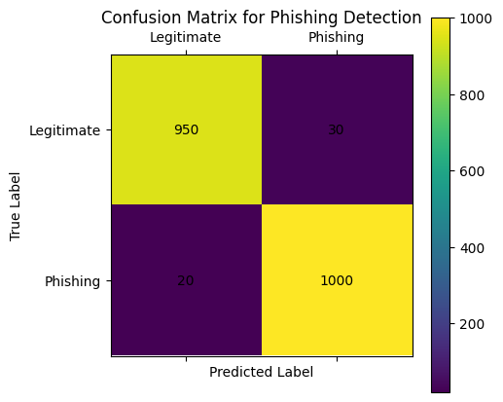
Figure 3: Confusion Matrix for Machine Learning-Based Phishing Website Detection
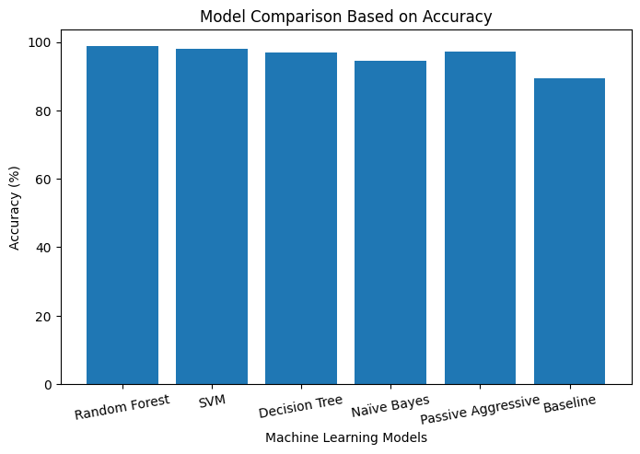
Figure 4: Model Comparison Bar Chart

5.2 Computational Efficiency

Machine Learning Model | Training Time (s) | Prediction Speed | Resource Utilization
Naive Bayes | Low | Very Fast | Low
Random Forest | High | Medium | High
Support Vector Machine | High | Medium | Medium
PAC | Low | Very Fast | Low
Table 3: Computational Efficiency
Computational efficiency plays an important role in evaluating the performance of machine learning models for phishing website detection. In this research, the models were analyzed based on their training time, prediction speed, and resource utilization. Algorithms such as Passive Aggressive Classifier and Naïve Bayes demonstrated faster training and prediction times due to their lower computational complexity, while Random Forest and Support Vector Machine (SVM) required comparatively higher processing time because of their advanced learning mechanisms. Despite the increased computational cost, Random Forest provided superior detection accuracy and reliability. The analysis highlights the trade-off between computational efficiency and classification performance in selecting suitable machine learning models for real-time phishing detection systems.

5.3 Cross-Validation Results
Cross validation results demonstrated the consistency and reliability of the machine learning models used for phishing website detection. The dataset was divided into multiple folds, and each model was trained and tested repeatedly using different data subsets. This process helped reduce overfitting and provided a more accurate evaluation of model performance on unseen data. The cross validation analysis showed that Random Forest and Support Vector Machine (SVM) achieved stable and high accuracy across different validation folds.

Fold 1 | Fold 2 | Fold 3 | Fold 4 | Fold 5 | Mean | Std. Dev.
99.61% | 99.50% | 99.58% | 99.62% | 99.57% | 99.58% | ±0.03%
Table 4: 5-Fold Stratified Cross-Validation Results
The results also indicated that advanced machine learning models maintained strong classification performance with minimal variation in accuracy scores during validation. Passive Aggressive Classifier and Decision Tree also produced reliable results with efficient prediction capability. The cross validation process confirmed that the selected models were capable of generalizing effectively and performing accurately in real-world phishing website detection scenarios.

5.4 Error Analysis
Error analysis was performed to identify the limitations and misclassification patterns of the machine learning models used for phishing website detection. The analysis focused on false positive and false negative predictions generated during testing. False positives occurred when legitimate websites were incorrectly classified as phishing, while false negatives occurred when phishing websites were identified as legitimate. These errors can affect the reliability and effectiveness of phishing detection systems, especially in real-world cybersecurity applications.

The analysis revealed that some models struggled to classify websites with highly similar phishing and legitimate URL patterns. Complex and newly generated phishing websites also increased the chances of misclassification. However, advanced models such as Random Forest and Support Vector Machine (SVM) produced fewer errors compared to baseline models due to their stronger learning capability and better feature handling. The findings from error analysis helped identify areas for improvement in feature extraction, preprocessing, and model optimization for future phishing detection systems.

5.5 Feature Analysis
Feature analysis was conducted to determine the importance and impact of different website and URL-related attributes in phishing website detection. Features such as URL length, HTTPS usage, domain age, special characters, redirection behavior, and DNS record availability were analyzed to identify their contribution to classification accuracy. The analysis showed that security-related and URL-based features played a major role in distinguishing phishing websites from legitimate ones.

The study also revealed that selecting relevant features improved the efficiency and performance of machine learning models. Removing unnecessary or less important features reduced computational complexity and helped the models focus on meaningful phishing patterns. Models such as Random Forest and Support Vector Machine (SVM) performed better when trained with optimized feature sets, resulting in higher detection accuracy and lower false positive rates.

6. Conclusion and Future Scope

6.1 Conclusion
This research presented a comparative evaluation of different machine learning models for phishing website detection using various URL-based and security-related features. Multiple algorithms, including Random Forest, Support Vector Machine (SVM), Decision Tree, Naïve Bayes, Passive Aggressive Classifier, and Baseline Classifier, were analyzed and compared using performance metrics such as accuracy, precision, recall, F1-score, and AUC score. The experimental results demonstrated that machine learning techniques are highly effective in identifying phishing websites and improving cybersecurity protection against online threats.

Among the evaluated models, Random Forest achieved the best overall performance due to its high accuracy, strong feature handling capability, and reduced false positive rates. The study also highlighted the importance of preprocessing, feature extraction, vectorization, and cross validation in improving phishing detection efficiency and reliability. Overall, the findings confirm that machine learning-based phishing detection systems can provide intelligent, accurate, and scalable solutions for protecting users from evolving phishing attacks and cyber fraud.

The research also demonstrated that feature analysis and proper data preprocessing significantly influence the performance of machine learning models. Features such as URL length, HTTPS usage, domain age, and redirection behavior played an important role in distinguishing phishing websites from legitimate ones. Cross validation results further confirmed the consistency and stability of the selected models, proving their ability to generalize effectively on unseen data. The comparative study helped identify the strengths and limitations of each algorithm in terms of classification accuracy, computational efficiency, and prediction capability.

In future work, the phishing detection system can be enhanced by integrating deep learning and hybrid machine learning approaches for improved detection of complex and newly generated phishing attacks. Real-time phishing detection systems can also be developed by combining machine learning models with browser extensions and cloud-based cybersecurity platforms. Additionally, larger and continuously updated datasets can be used to improve model adaptability and robustness against evolving cyber threats. These improvements can contribute to the development of more advanced and intelligent cybersecurity solutions for protecting users and organizations from phishing attacks

6.2 Future Scope
The future scope of this research includes the integration of advanced deep learning techniques for improving phishing website detection accuracy. Models such as Artificial Neural Networks (ANN), Recurrent Neural Networks (RNN), and Long Short-Term Memory (LSTM) networks can be explored to identify complex phishing patterns and hidden relationships within URLs and website content. These advanced approaches may provide better adaptability against evolving phishing attacks and improve real-time detection capabilities.

Another important future direction is the development of real-time phishing detection systems integrated with web browsers, email platforms, and cloud-based security services. Such systems can provide instant alerts and automated protection against malicious websites and phishing links. Combining machine learning models with browser extensions and cybersecurity frameworks can help enhance user safety and reduce the risk of online fraud and identity theft.

Future research can also focus on improving feature engineering and dataset diversity for more accurate phishing classification. Using larger and continuously updated datasets collected from multiple cybersecurity sources can help machine learning models adapt to newly emerging phishing techniques. Additional website behavioral features, webpage content analysis, and network traffic patterns can also be included to strengthen detection performance and reduce false positive rates.

Furthermore, hybrid and ensemble machine learning approaches can be explored to improve the efficiency and reliability of phishing detection systems. Combining multiple algorithms may help achieve better classification accuracy, computational efficiency, and robustness against sophisticated cyberattacks. Future systems can also incorporate artificial intelligence-based threat intelligence and automated learning mechanisms to continuously update detection models and respond effectively to evolving cybersecurity threats.
REFERENCES

1. Basnet, R., Mukkamala, S., Sung, A.H.: Detection of phishing attacks: A machine learning approach. In: Soft Computing Applications in Industry (2008).
2. Ma, J., Saul, L.K., Savage, S., Voelker, G.M.: Beyond blacklists: learning to detect malicious web sites from suspicious URLs. In: ACM SIGKDD (2009).
3. Mohammad, R.M., Thabtah, F., McCluskey, L.: Predicting phishing websites based on self-structuring neural network. Neural Computing and Applications 25(2), 443–458 (2014).
4. Sahingoz, O.K., Buber, E., Demir, O., Diri, B.: Machine learning based phishing detection from URLs. Expert Systems with Applications 117, 345–357 (2019).
5. Rao, R.S., Pais, A.R.: Detection of phishing websites using an efficient feature-based machine learning framework. Neural Computing and Applications 31, 3851–3873 (2019).
6. Chiew, K.L., Yong, K.S.C., Tan, C.L.: A survey of phishing attacks: their types, vectors and technical approaches. Expert Systems with Applications 106, 1–20 (2018).

